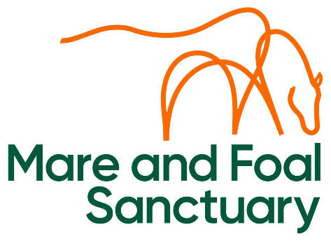

EMPLOYMENT APPLICATION FORM

POSITION APPLIED FOR: ……………………………………………………………

PERSONAL DETAILS
Forename(s):
Surname:
Telephone No: | Home: | Mobile:
Current Address: | Post Code:
Are there any restrictions on your right to work in the UK? |  |  | YES | NO
Are you over the age of 18? |  |  | YES | NO
Have you previously worked for the Sanctuary? |  |  | YES | NO

EDUCATION AND TRAINING

Secondary Education Details and Examinations Taken: | Qualifications/Results
Name/Address of Establishment:

Further Education Details and Examinations Taken: | Qualifications/Results
Name/Address of Establishment:

Any Other Exams/Training that may be Relevant to this Application: | Qualifications/Results

EMPLOYMENT DETAILS
Please give details of your past employment, starting with the most recent. Continue on a separate sheet if required.

Name and Address of Employer | Dates of Employment | Position Held and Main Duties |  | Reason for Leaving
Name and Address of Employer | Dates of Employment | Position Held and Main Duties |  | Reason for Leaving
Name and Address of Employer | Dates of Employment | Position Held and Main Duties |  | Reason for Leaving
Do you have any secondary employment? (part time, evenings, etc)?  If yes, please give details: |  |  | YES |  | NO

REFEREES
Please give the names of two people whom we may approach for a reference, one of which should be your current or most recent employer.

Can we approach your current employer before an offer of employment is made? |  | YES | NO
Name: | Name:
Position: | Position:
Company Name/Address: | Company Name/Address:
Telephone Number: | Telephone Number:

PERSONAL STATEMENT

Please supply a statement of the personal qualities and experience that you believe are relevant to your suitability for the post and how you meet the personal specification.

OTHER DETAILS

How did you hear of this vacancy?

Do you require any special arrangements for your interview on account of a disability? |  | YES | NO
If "yes", please provide further any information that you feel would help us to accommodate your needs during your interview and thus meet our obligations under the Equality Act 2010:

If offered employment, you will be required to complete a Medical Questionnaire. If required, are you prepared to undergo a medical examination before starting employment? |  | YES | NO
I confirm that the information given in this form is complete and accurate. I understand that any false information or deliberate omissions will disqualify me from employment or may render me liable to summary dismissal.

I understand these details will be held in confidence by the Sanctuary, for the purpose of ongoing personnel administration and payroll administration in compliance with the UK GDPR and Data Protection Act 2018. I undertake to notify the Sanctuary immediately of any changes to the above details.

Signed: | Date:

